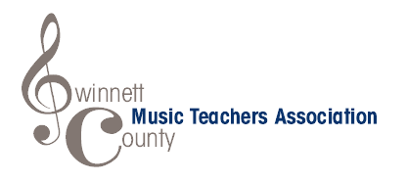
MED/PED (MUSIC EDUCATION/PEDAGOGY)
SCHOLARSHIP APPLICATION

Name______________________________School_____________________________
Area of Performance_______________________Phone_________________________
Home Address__________________________________________________________
Teacher’s Name__________________________ Phone_________________________
Teacher’s Email Address__________________________________________________
University that you will attend______________________________________________
Intended Major__________________________________________________________
The applicant has participated in the following GCMTA sponsored event in the preceding twelve (12) months:

We have read and understand the rules of the GCMTA MED/PED Scholarship.
_____________________________________________
Student’s Signature

_____________________________________________
Teacher’s Signature

- Please include a 350 word or less essay describing why music education or pedagogy is an important career path to pursue.
- You must submit the URL of an online video of your performance of any repertoire on your chosen instrument. Memorization is not required, and the performance may not exceed ten (10) minutes.
- The deadline to submit your application is May 1, 2020.

